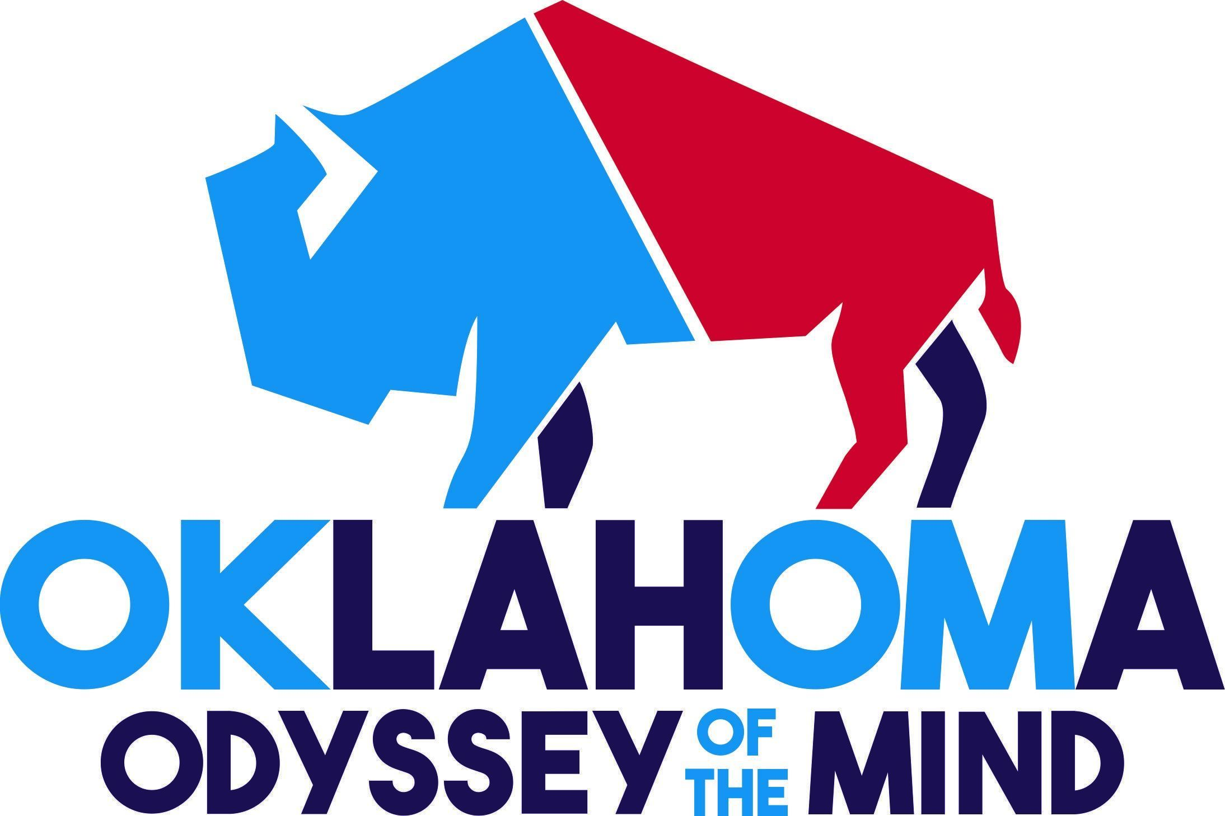

**Photo Release Form**

*Oklahoma Creativity, Inc.*

*Each participating team member, coach and official must fill out a copy of this form and submit it at the Regional Qualifying Tournament. Persons under 18 years of age must have their parent or guardian sign. (Your signature on this form permits the organizers and sponsors of the Odyssey of the Mind program to use videos and photographs of participants in public showings such as the Awards Ceremony or performances.) Your name will not be publicized unless we ask for additional permission and it is granted by you.*

Subject: Oklahoma Odyssey of the Mind™ Regional Tournament, State Tournament 2025.

Locations: Oklahoma State University, Tulsa, OK

Oklahoma State University, Stillwater, OK

I grant to Oklahoma Creativity, Inc. its representatives and employees the right to take photographs of me and my property in connection with the above-identified subject. I authorize Oklahoma Creativity, Inc., its assigns and transferees to copyright, use and publish the same in print and/or electronically.

I agree that Oklahoma Creativity, Inc., may use such photographs of me with or without my name and for any lawful purpose, including for example such purposes as publicity, illustration, advertising and Web content including social media platforms.

I have read and understand the above.

Signature: __________________________________________

Printed Name: ______________________________________

Organization Name (if applicable) _______________________

Address: ___________________________ City:___________________________ St:______

Date: __________________________

Signature of parent or guardian if under age 18:____________________ ___________________